**Boxplot and Whisker plot**

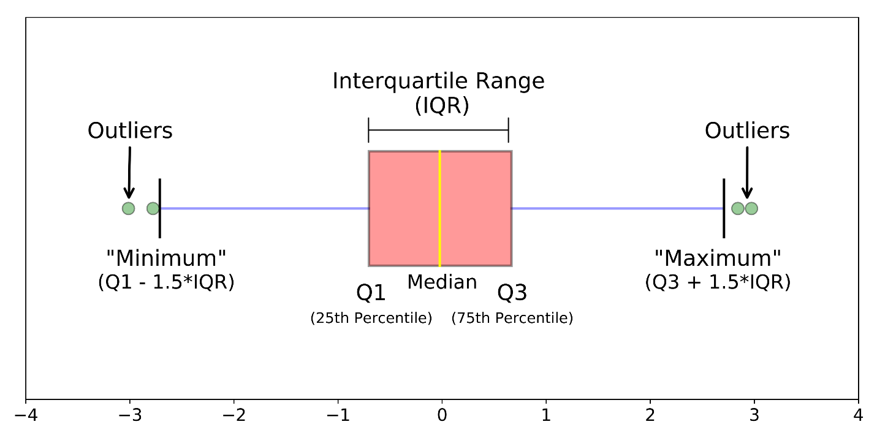

Different parts of a boxplot

The image above is a boxplot**.**A boxplot is a standardized way of displaying the distribution of data based on a five number summary (“minimum”, first quartile (Q1), median, third quartile (Q3), and “maximum”). It can tell you about your outliers and what their values are. It can also tell you if your data is symmetrical, how tightly your data is grouped, and if and how your data is skewed.

This tutorial will include:

* What is a boxplot?
* Understanding the anatomy of a boxplot by comparing a boxplot against the probability density function for a normal distribution.
* How do you make and interpret boxplots using Python?

**What is a Boxplot?**

For some distributions/datasets, you will find that you need more information than the measures of central tendency (median, mean, and mode).

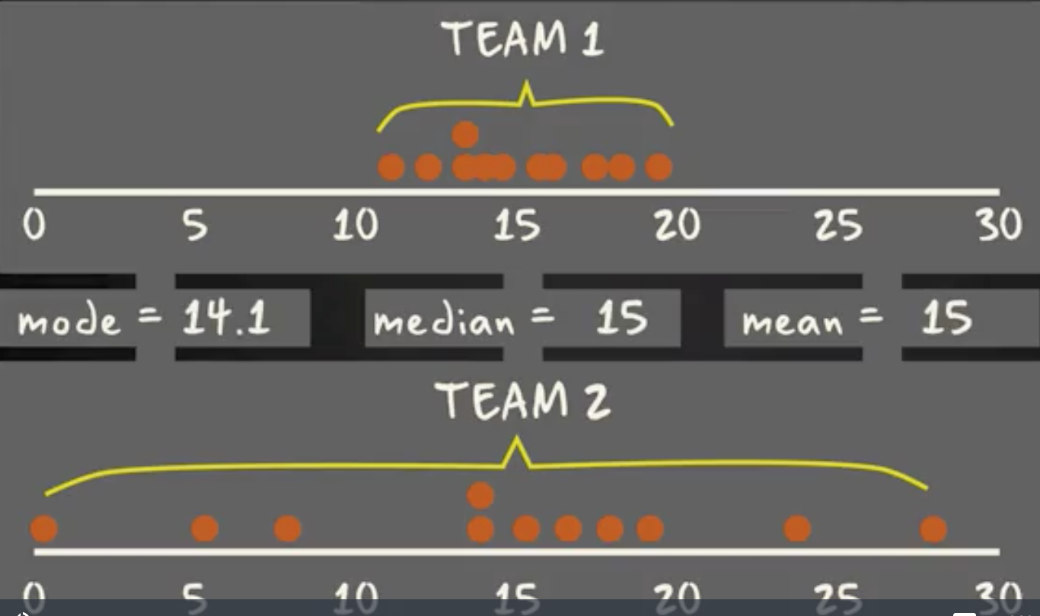

There are times when mean, median, and mode aren’t enough to describe a dataset (taken from [here](https://www.coursera.org/lecture/basic-statistics/1-05-range-interquartile-range-and-box-plot-RbWIZ)).

You need to have information on the variability or dispersion of the data. A boxplot is a graph that gives you a good indication of how the values in the data are spread out. Although box lots may seem primitive in comparison to a [histogram](https://datavizcatalogue.com/methods/histogram.html) or [density plot](https://datavizcatalogue.com/methods/density_plot.html), they have the advantage of taking up less space, which is useful when comparing distributions between many groups or datasets.



Different parts of a boxplot

Boxplots are a standardized way of displaying the distribution of data based on a five number summary (“minimum”, first quartile (Q1), median, third quartile (Q3), and “maximum”).

**median (Q2/50th Percentile)**: the middle value of the dataset.

**first quartile (Q1/25th Percentile)**: the middle number between the smallest number (not the “minimum”) and the median of the dataset.

**third quartile (Q3/75th Percentile)**: the middle value between the median and the highest value (not the “maximum”) of the dataset.

**interquartile range (IQR)**: 25th to the 75th percentile.

**whiskers (shown in blue)**

**outliers (shown as green circles)**

**“maximum”**: Q3 + 1.5*IQR

**“minimum”**: Q1 -1.5*IQR

What defines an outlier, “minimum”, or“maximum” may not be clear yet. The next section will try to clear that up for you.

**Boxplot on a Normal Distribution**

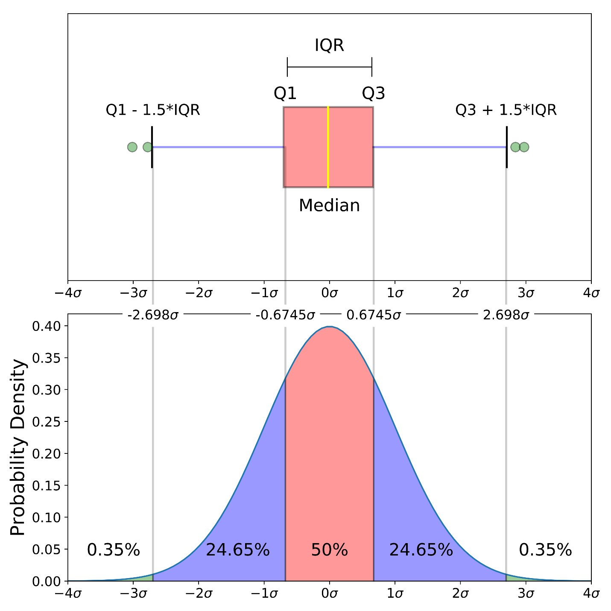

Comparison of a boxplot of a nearly normal distribution and a probability density function (pdf) for a normal distribution

The image above is a comparison of a boxplot of a nearly normal distribution and the probability density function (pdf) for a normal distribution. The reason why I am showing you this image is that looking at a statistical distribution is more commonplace than looking at a box plot. In other words, it might help you understand a boxplot.

This section will cover many things including:

* How outliers are (for a normal distribution) .7% of the data.
* What a “minimum” and a “maximum” are

**Probability Density Function**

This part of the post is very similar to the [68–95–99.7 rule article](https://towardsdatascience.com/understanding-the-68-95-99-7-rule-for-a-normal-distribution-b7b7cbf760c2), but adapted for a boxplot. To be able to understand where the percentages come from, it is important to know about the probability density function (PDF). A PDF is used to specify the probability of the [random variable](https://en.wikipedia.org/wiki/Random_variable)falling *within a particular range of values*, as opposed to taking on any one value. This probability is given by the [integral](https://en.wikipedia.org/wiki/Integral) of this variable’s PDF over that range — that is, it is given by the area under the density function but above the horizontal axis and between the lowest and greatest values of the range. This definition might not make much sense so let’s clear it up by graphing the probability density function for a normal distribution. The equation below is the probability density function for a normal distribution

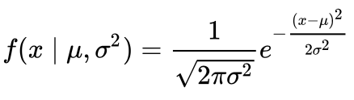

PDF for a Normal Distribution

Let’s simplify it by assuming we have a mean (μ) of 0 and a standard deviation (σ) of 1.

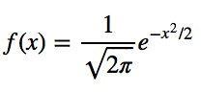

PDF for a Normal Distribution

This can be graphed using anything, but I choose to graph it using Python.

# Import all libraries for this portion of the blog post  
from scipy.integrate import quad  
import numpy as np  
import matplotlib.pyplot as plt  
%matplotlib inlinex = np.linspace(-4, 4, num = 100)  
constant = 1.0 / np.sqrt(2*np.pi)  
pdf_normal_distribution = constant * np.exp((-x**2) / 2.0)  
fig, ax = plt.subplots(figsize=(10, 5));  
ax.plot(x, pdf_normal_distribution);  
ax.set_ylim(0);  
ax.set_title('Normal Distribution', size = 20);  
ax.set_ylabel('Probability Density', size = 20);

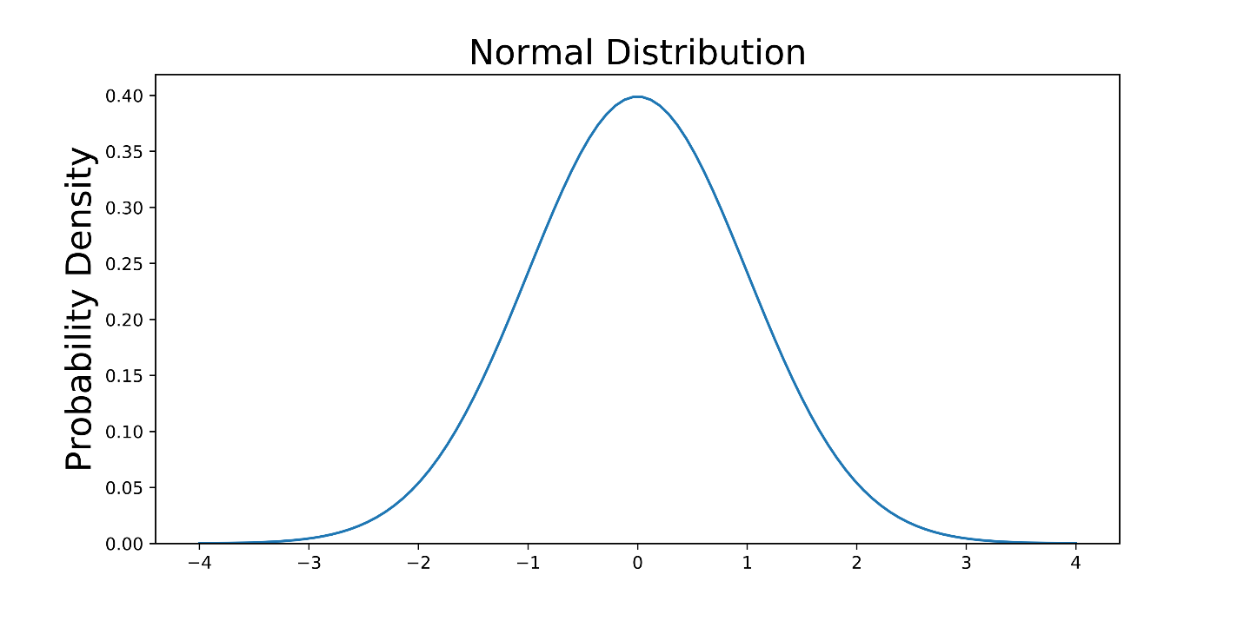

The graph above does not show you the *probability* of events but their *probability density.*To get the probability of an event within a given range we will need to integrate. Suppose we are interested in finding the probability of a random data point landing within the interquartile range .6745 standard deviation of the mean, we need to integrate from -.6745 to .6745. This can be done with SciPy.

# Make PDF for the normal distribution a function  
def normalProbabilityDensity(x):  
 constant = 1.0 / np.sqrt(2*np.pi)  
 return(constant * np.exp((-x**2) / 2.0) )# Integrate PDF from -.6745 to .6745  
result_50p, _ = quad(normalProbabilityDensity, -.6745, .6745, limit = 1000)  
print(result_50p)

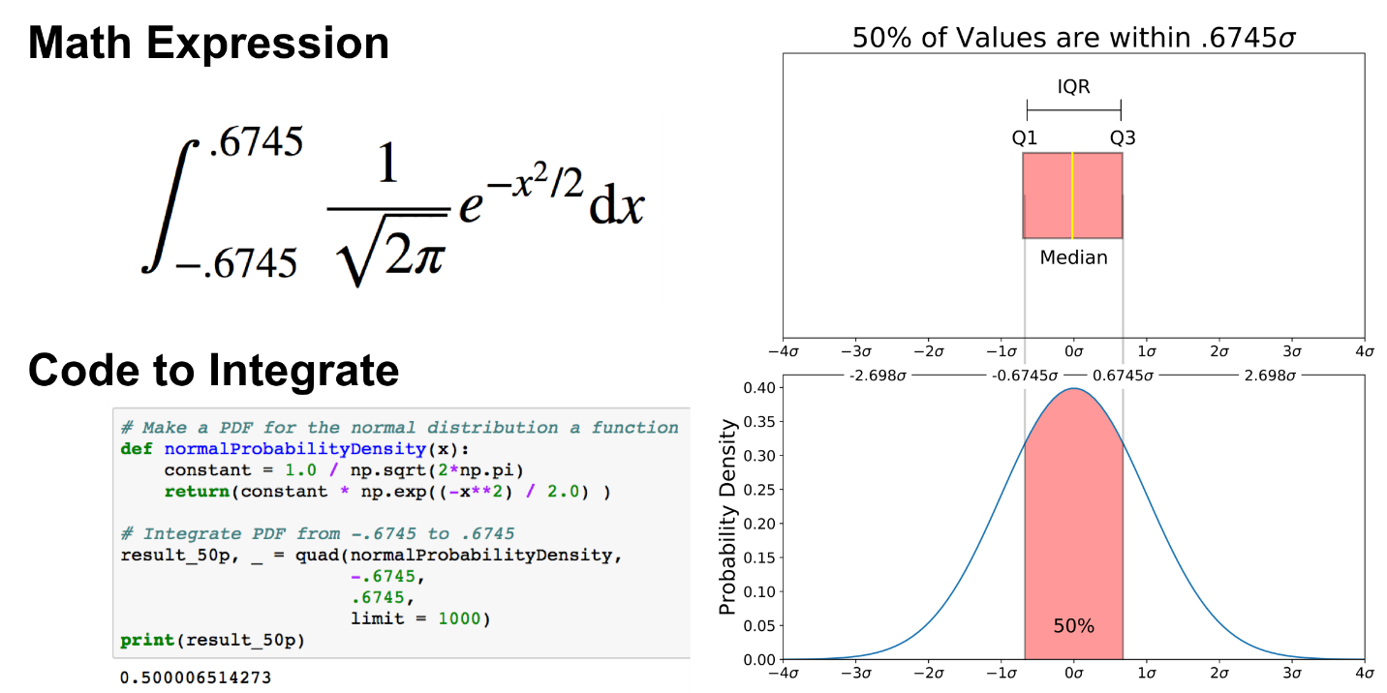

The same can be done for “minimum” and “maximum”.

# Make a PDF for the normal distribution a function  
def normalProbabilityDensity(x):  
 constant = 1.0 / np.sqrt(2*np.pi)  
 return(constant * np.exp((-x**2) / 2.0) )# Integrate PDF from -2.698 to 2.698  
result_99_3p, _ = quad(normalProbabilityDensity,  
 -2.698,  
 2.698,  
 limit = 1000)  
print(result_99_3p)

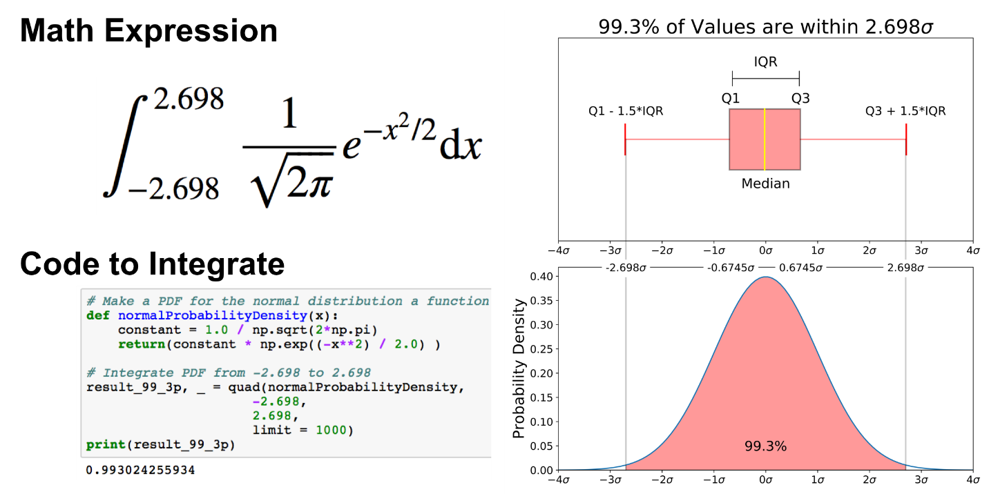

As mentioned earlier, outliers are the remaining .7% percent of the data.

It is important to note that for any PDF, the area under the curve must be 1 (the probability of drawing any number from the function’s range is always 1).

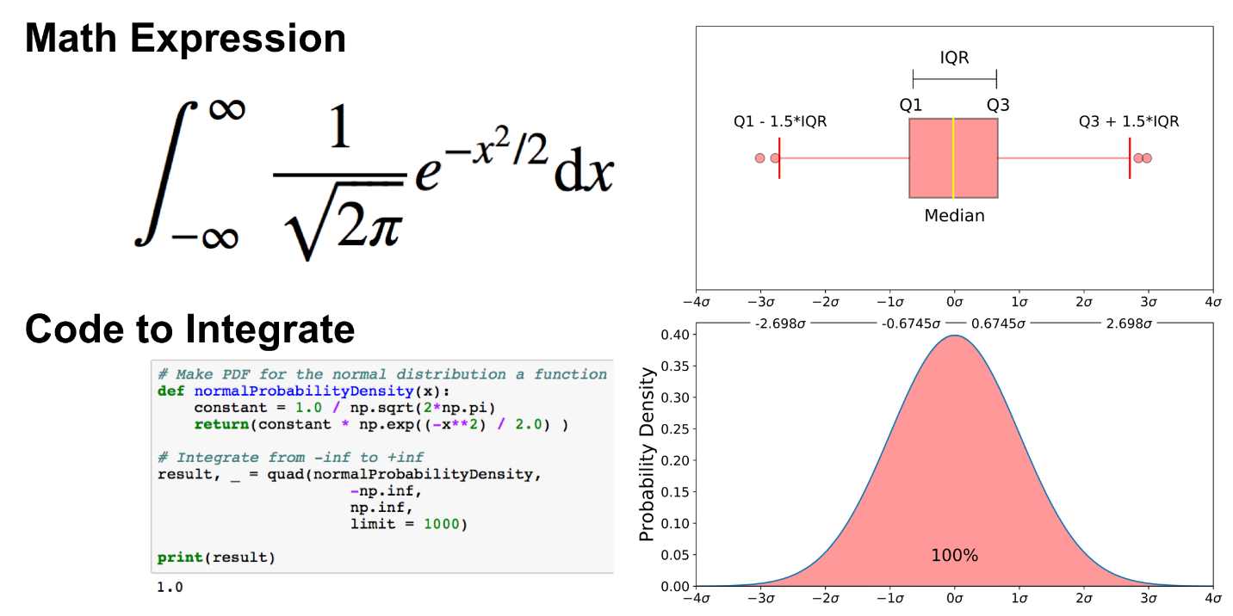

**Graphing and Interpreting a Boxplot**

Obviously you won’t always have an underlying normal distribution for a boxplot. Let’s use the [Breast Cancer Wisconsin (Diagnostic) Data Set](https://www.kaggle.com/uciml/breast-cancer-wisconsin-data#data.csv) to show how to utilize a boxplot on real data. If you don’t have a Kaggle account, you can download the dataset from [my github](https://raw.githubusercontent.com/mGalarnyk/Python_Tutorials/master/Kaggle/BreastCancerWisconsin/data/data.csv).

Kaggle dataset link : <https://www.kaggle.com/uciml/breast-cancer-wisconsin-data#data.csv>

Git Hub Data Set Link : <https://raw.githubusercontent.com/mGalarnyk/Python_Tutorials/master/Kaggle/BreastCancerWisconsin/data/data.csv>

**Read in the data**

The code below reads the data into a pandas dataframe.

import pandas as pd  
import seaborn as sns  
import matplotlib.pyplot as plt# Put dataset on my github repo   
df = pd.read_csv('<https://raw.githubusercontent.com/mGalarnyk/Python_Tutorials/master/Kaggle/BreastCancerWisconsin/data/data.csv>')

**Graph Boxplot**

A boxplot is used below to analyze the relationship between a categorical feature (malignant or benign tumor) and a continuous feature (area_mean).

There are a couple ways to graph a boxplot through Python. You can graph a boxplot through seaborn, pandas, or seaborn.

**seaborn**

The code below passes the pandas dataframe df into seaborn’s boxplot.

sns.boxplot(x='diagnosis', y='area_mean', data=df)

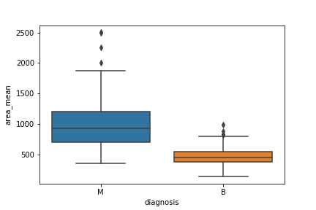

**matplotlib**

The boxplots you have seen in this post were made through matplotlib. This approach can be far more tedious, but can give you a greater level of control.

malignant = df[df['diagnosis']=='M']['area_mean']  
benign = df[df['diagnosis']=='B']['area_mean']fig = plt.figure()  
ax = fig.add_subplot(111)  
ax.boxplot([malignant,benign], labels=['M', 'B'])

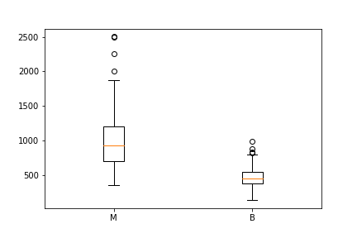

You can make this a lot prettier with a little bit of work

**pandas**

You can plot a boxplot by invoking .boxplot() on your DataFrame. The code below makes a boxplot of the area_mean column with respect to different diagnosis.

df.boxplot(column = 'area_mean', by = 'diagnosis');  
plt.title('')

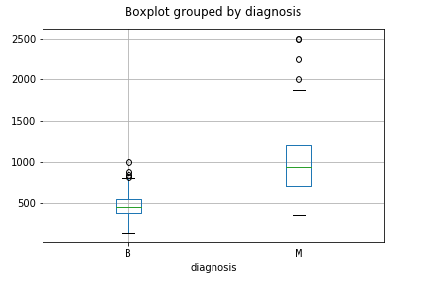

**Notched Boxplot**

The notched boxplot allows you to evaluate confidence intervals (by default 95% confidence interval) for the medians of each boxplot.

malignant = df[df['diagnosis']=='M']['area_mean']  
benign = df[df['diagnosis']=='B']['area_mean']fig = plt.figure()  
ax = fig.add_subplot(111)  
ax.boxplot([malignant,benign], notch = True, labels=['M', 'B']);

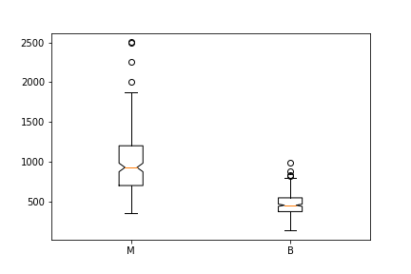

Not the prettiest yet.

**Interpreting a Boxplot**

Data science is about communicating results so keep in mind you can always make your boxplots a bit prettier with a little bit of work

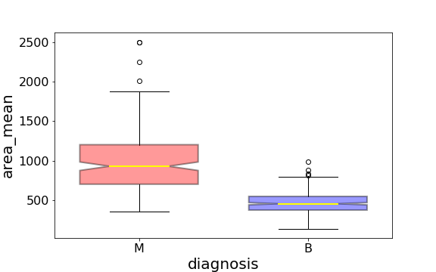

Link to download the code of some box plot examples : <https://github.com/mGalarnyk/Python_Tutorials/blob/master/Statistics/boxplot/Box_plot_interpretation.ipynb>

Using the graph, we can compare the range and distribution of the area_mean for malignant and benign diagnosis. We observe that there is a greater variability for malignant tumor area_mean as well as larger outliers.

Also, since the notches in the boxplots do not overlap, you can conclude that with 95% confidence, that the true medians do differ.

Here are a few other things to keep in mind about boxplots:

1. Keep in mind that you can always [pull out the data from the boxplot](https://stackoverflow.com/questions/33518472/getting-data-of-a-boxplot-pandas) in case you want to know what the numerical values are for the different parts of a boxplot.
2. Matplotlib does **not** estimate a normal distribution first and calculates the quartiles from the estimated distribution parameters. The median and the quartiles are calculated directly from the data. In other words, your boxplot may look different depending on the distribution of your data and the size of the sample, e.g., asymmetric and with more or less outliers.

[Pull out the data from the boxplot](https://stackoverflow.com/questions/33518472/getting-data-of-a-boxplot-pandas)

One option is to use the y data from the plots - probably most useful for the outliers (fliers)

1. _, bp = pd.DataFrame.boxplot(df, return_type='both')
2. outliers = [flier.get_ydata() for flier in bp["fliers"]]
3. boxes = [box.get_ydata() for box in bp["boxes"]]
4. medians = [median.get_ydata() for median in bp["medians"]]
5. whiskers = [whiskers.get_ydata() for whiskers in bp["whiskers"]]

But it's probably more straightforward to get the other values (including IQR) using either

1. quantiles = df.quantile([0.01, 0.25, 0.5, 0.75, 0.99])

or, as suggested by WoodChopper

1. stats = df.describe()

Reference : <https://towardsdatascience.com/understanding-boxplots-5e2df7bcbd51>